CICADA 3301 recruiting round 2 2013

Page 1 of 3 [38 Posts] | Goto page: 1, 2, 3 Next

 | Author |  | Message
 | bambusar  Unfettered    Joined: 02 May 2012  Posts: 639 |  | CICADA 3301 recruiting round 2 2013  ARG like set of puzzles that proved to be recruiting in some secret group  I dont know how well you are informed with CICADA 3301 puzzles from 2012.    Basically it is recruitment quest of puzzles based on classical literature and pretty hard core encrypting.  It strated for the first time (that i know of) in january 2012. This is its second draft that started in 5th january with post on 4chan.  Common thing that sticks out from every Cicada 3301 puzzle are PRIME NUMBERS. Beautiful PRIME NUMBERS.  People who solved both puzzles they got on emails were invited to secret group consistent of people who were able so solve same puzzle. Not much is known what those people were doing after that. It is a secret afterall.  Here I will post all the links and all the stuff you need to know.  CICADA 3301 January 2012 (base info about last years challenges)  http://i.imgur.com/2Zeo6.jpg start  http://i.imgur.com/TpntC.jpg end  Articles:  http://www.istartedsomething.com/20120121/cicada-3301-cryptographic-puzzle-game-played-out-on-4chan-reddit-best-job-hire-in-disguise/  https://github.com/bibanon/bibanon/wiki/Cicada-3301-wiki  http://www.clevcode.org/cicada-3301/  http://www.mentalfloss.com/blogs/archives/156708  http://bernsteinbear.com/cicada  Pastebins:  http://pastebin.com/cfHmiCHi last public message from legit cicada  http://pastebin.com/RmqxWcnB leaked mail that people got when they solve last puzzle <----- this is a bit about cicadas beliefs and what they stand for  http://pastebin.com/V62m76fN confession of fake wind troll was published afterwards  http://pastebin.com/4nrDxVXk main two puzzles you had to solve to get invitation, prior to that you had to solve clues from literature and reddit to find onion links to submit your email
Posted: Sun Jan 06, 2013 1:29 pm
Last edited by bambusar on Sun Dec 01, 2013 7:13 pm; edited 2 times in total
 | bambusar  Unfettered    Joined: 02 May 2012  Posts: 639 |  | CICADA 3301 round 2 in 2013  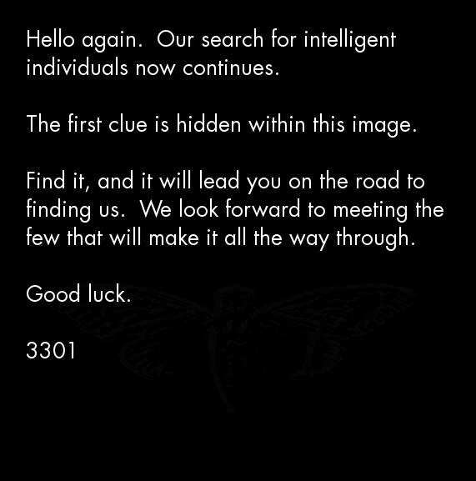  OK down to business!  This image was posted on 4chan in multiple thread by we dont know who on 5th January. It consist image that when outguessed (stego tool) produce this http://pastebin.com/C5G2fNPR with legit PGP signature cicada used last year. So source IS CONFIRMED.  There was one similar thread one day earlier full with old images and few interesting links and leads, but in that thread there was NO LEGIT CICADAS PGP signature, so we dont have any idea who eas posting it and how legit things there was.  Here is the post that was on 4chan on 4th Jan .  http://chanarchive.org/4chan/b/65987/it-s-been-a-year-now-have-there-been-any-more-threads-like-this-since  Jan 4th 2013  Note: I have no proofs that any legit cicada people were in this thread. But there was alot of guys that made some miraculous discoveries and few people who were bumping the thread so it didnt die. There sure was some preparation and few coordinated people involved in that thread.  Also note that Cicada hinted that there will be more recruiting rounds in last message from last year. http://i.imgur.com/TpntC.jpg  This are things from last 4chan thread that looks like legit clues, I wasnt able to confirm any of them as being legit, yet! No PGP signed official message was given so far!  miracle no1:  CONTROVERSIAL PASTEBIN (this document rised alot of dust) there are few differant theories what is the reason someone released it. It was writen with much care. Interpret it as you feel like.  http://pastebin.com/dHJ6JNkr guy who found it was incredibly luck and he claimed he isnt author of it  People who read it usualy react in one of two ways:  1. wow this is cleverly structured organization fighting for basic human rights and freedom  2. wow this looks like cult of some sort  To me it looks like it was written to attract some people and to lead some people off. You can understand it as you wish, that is your right.  You get what you bring in!  miracle no2:  Code:  I´m actually found something weird.  Do you know sms4tor?(http://sms4tor3vcr2geip.onion/)  I took the first 52 digits of the pgp key from >>448463952.  I got this message:  "You are near. The Mandelbrot set near the event horizon is the last clue."  -3301"  what are the chances to find something like that on random??  to use some random part of some random pgp key someone posted and came from last year?  he is referring to that image http://imgur.com/e4RE2  btw that image is publicly posted on few sites and all people from last year have it...  Code:  "I doubt not, i had coincidental sms4tor open at the moment so I gave it a try. What sort of verify you think of?"  this was his answer how he found it... sounds fake as hell  Clue people found by goggling Mandelbrot  http://www.butterflyeffect.ca/FractalCosmology/CloseToTheEdge.pdf
 |  |  | Posted: Sun Jan 06, 2013 1:48 pm
 | bambusar  Unfettered    Joined: 02 May 2012  Posts: 639 |  | 5.1.2013  Shit got real we have confirmed CICADA 3301 round 2  with PGPs and all that  http://i.imgur.com/BhjYK.jpg  Here is ourguess (stego tool) output.  http://pastebin.com/C5G2fNPR  book is http://www.sacred-texts.com/oto/engccxx.htm  applying book code to text produced this link  https://www.dropbox.com/s/r7sgebdtmzj14s/3301  File consist of LINUX boot CD  DATA FOLDER with 3 files  MP3 song  •Recording of what happens when you boot that linux CD  source code http://pastebin.com/sSJgTKQD (contains legit PGP)  1.  http://www.youtube.com/watch?v=KG3GCWkJZ0I  2.  •Mp3 song:  Song is palindromic. As the twitter account number and numbers 3301 1033 where linux distribution stops for 2 seconds.  If you open MP3 in text editor you will found hidden poem in it  https://pastee.org/ujpxy  •DATA FOLDER:  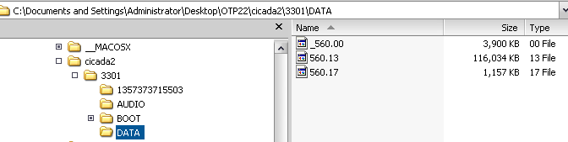  Number printed in final message in LINUX Boot sequence:  1231507051321 It is a beautiful PRIME, palindromic also  http://primes.utm.edu/curios/page.php/1231507051321.html  People found this twitter account.  https://twitter.com/1231507051321
Posted: Sun Jan 06, 2013 2:02 pm
Last edited by bambusar on Sun Jan 06, 2013 2:14 pm; edited 2 times in total
 | bambusar  Unfettered    Joined: 02 May 2012  Posts: 639 |  | If you fought through previous posts and you are still reading this you are probably interested in joining people who are solving the puzzle.  that are the people we seek for, since currently we are stuck on twitter account encrapted messageds, DATA folder and poem hidden in mp3 file.  You can find people solving it here:  chat http://webchat.freenode.net/?channels=#33012013  wiki:  http://uncovering-cicada.wikia.com/wiki/Status  http://uncovering-cicada.wikia.com/wiki/What_We_Know  http://uncovering-cicada.wikia.com/wiki/Uncovering_Cicada_Wiki
 |  |  | Posted: Sun Jan 06, 2013 2:05 pm
 | netsua98  Unfettered    Joined: 22 Dec 2011  Posts: 449  Location: Florida |  | I dont know seems intresting but cult or what? Hackers? Terrorist?
_________________
ARGing, Authoring, PMing, Producing, Composing, Living
Posted: Sun Jan 06, 2013 9:59 pm
 | ndemeter  Entrenched  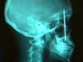  Joined: 28 Jul 2004  Posts: 1004  Location: Sunny California! |  | Hm, what's the twitter account doing? Are those fragments of the PGP key that are being posted?
_________________
Twitter: NickoDM - XBL: NickoDM
Posted: Mon Jan 07, 2013 2:36 pm
 | MrToasty  I Have 100 Cats and Smell of Wee    Joined: 03 Aug 2004  Posts: 4256  Location: Des Moines, IA |  | ndemeter wrote:  Hm, what's the twitter account doing? Are those fragments of the PGP key that are being posted?  Check out the wiki page for an explanation, although can be a bit hard to follow.
 |  |  | Posted: Mon Jan 07, 2013 3:29 pm
 | Greystone  Unfettered    Joined: 02 Jan 2008  Posts: 373 |  | This has all of the marking of "The Darkest Puzzle" from 2010/11  Packages came from Australia but drops were all over the world.  There is a definite agenda.  For those who don't know this particular ARG "The Darkest Puzzle" It was someones twisted take on 9/11 with an anti-semtic theory and NO real truth.
 |  |  | Posted: Mon Jan 07, 2013 6:30 pm
 | bambusar  Unfettered    Joined: 02 May 2012  Posts: 639 |  | I apologize, not much time to explain.  Quite hard to organize community since people expect it is rerouting based on last years experiences and arent really prepared to put enough energy in community and making player base efficient. Most players when they solve part of the puzzle dont have any interest to provide clues and procedures for others who will came in game later. But i guess things will get better with time.  Check new developments here:  http://uncovering-cicada.wikia.com/wiki/Twitter_is_jpg_theory#TOR_2_PAGE_IS_DOWN  We are still  http://webchat.freenode.net/?channels=#33012013  And no it is not cult. At leatst i doesnt seem like it to me. Intention of that "religious" (http://pastebin.com/dHJ6JNkr) pastebin is to keep certain profile of people away from it. I think so at least. It certanly cause alto of people to say this is acult and disband it. Funny thing people who are in channel arent even remotely religious. Hackers community is better guess I think.  About "The Darkest Puzzle" from 2010/11 . I know nothing about it. I know about cicada 3301 in jan 2012 and cicada 3301 in jan 2013. Based on pastebins explaining a bit about nature and organization of Cicada 3301 i could suspect that they did many similar rerouting ARGs. Maybe worth checking if there is any connection.  Image made from tweeter feeds by xoring it with DATA files from dropbox link. There is hidden Outguess message in it. More in wiki. ^  http://imgur.com/c23zn  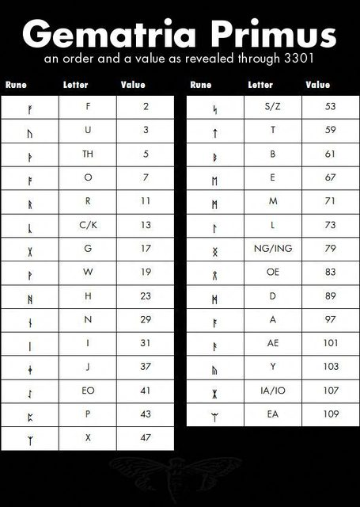
Posted: Tue Jan 08, 2013 3:49 am
Last edited by bambusar on Tue Jan 08, 2013 4:01 am; edited 2 times in total
 | bambusar  Unfettered    Joined: 02 May 2012  Posts: 639 |  | I will post few links to youtube videos that might motivate you to loog deeper into cryptography, PGP, RSA, TOR...  Apparently they believe in absolute freedom. Individual and the information. I can connect to that thought.  FEW LECTURES FROM C3 (hackers convention in Germany, similar to DEFCON)  Jacob Appelbaum 29C3 Keynote: Not My Department  http://www.youtube.com/watch?v=QNsePZj_Yks  Cory Doctorow: The coming war on general computation [28C3]  http://www.youtube.com/watch?v=yYqkU1y0AYc  29C3 Panel: Jesselyn Radack, Thomas Drake, William Binney on whistleblowing and surveillance  http://www.youtube.com/watch?v=XDM3MqHln8U  ^ shocking stories from converted Americans that decided not to work for the dark side anymore. Former attorney, spy plane pilot and nsa agent confessions.  FactHacks RSA security and prime factorization[29c3]  http://www.youtube.com/watch?v=IuSnY_O8DqQ  How governments have tried to block Tor [28C3]  http://www.youtube.com/watch?v=GwMr8Xl7JMQ  2 SHORTER VIDEOS  Keiser Report: Happy Hacking! (ft. Richard Stallman) (E344)  http://youtu.be/3o82P4V1vu0?t=12m34s <--Stallman nicely explaining why hackers arent bad, why anonymous arent evil and why ddosing sholdnt be illegal  http://www.youtube.com/watch?v=HkM6dj-qR4E&feature=edu&list=PLB4D701646DAF0817  Gambling with Secrets: Part 2/8 (Prime Factorization)  cryptography basics and why primes are so important  Second image we xored from DATA files and mp3 from dropbox CD  
 |  |  | Posted: Tue Jan 08, 2013 3:50 am
 | bambusar  Unfettered    Joined: 02 May 2012  Posts: 639 |  | one more video  Growing State Surveillance: National Security Agency Whistleblower William Binney (April 20, 2012)  http://youtu.be/zq3fgwV7doY?t=45m54s  Top comment:  Code:  TheFortressAmerica 4 months ago  By watching this we are all in the database. Welcome to the party! I'll bring the﻿ doritos and beer.
 |  |  | Posted: Wed Jan 09, 2013 9:49 am
 | bambusar  Unfettered    Joined: 02 May 2012  Posts: 639 |  |   source CICADA OS splash screen.
 |  |  | Posted: Thu Jan 10, 2013 6:22 pm
 | bambusar  Unfettered    Joined: 02 May 2012  Posts: 639 |  | DIAGRAM WITH CURRENT PROGRESS  http://i.imgur.com/qR9by.png 1000px width  http://i.imgur.com/J4WRL.jpg 2000px width  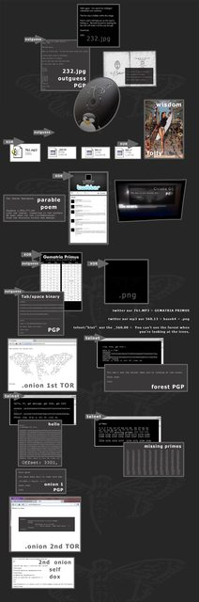
 |  |  | Posted: Thu Jan 10, 2013 8:42 pm
 | bambusar  Unfettered    Joined: 02 May 2012  Posts: 639 |  | http://imgur.com/ggoOj DIAGRAM UPDATED  green rope knots are loose ends
 |  |  | Posted: Sun Jan 13, 2013 12:31 pm
 | bambusar  Unfettered    Joined: 02 May 2012  Posts: 639 |  | We got additional clue on onion 2 (onion ver 2.2)  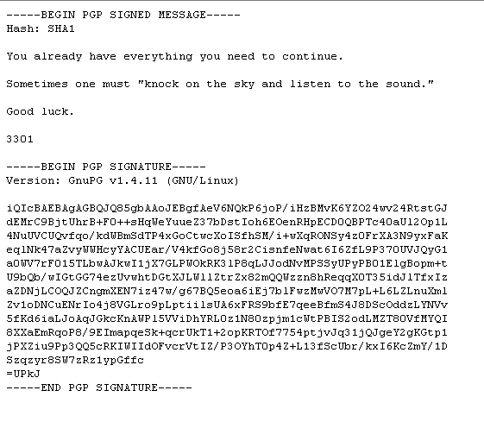  But it is basically telling us we are missing something.  So now we have two esoteric messages like this.  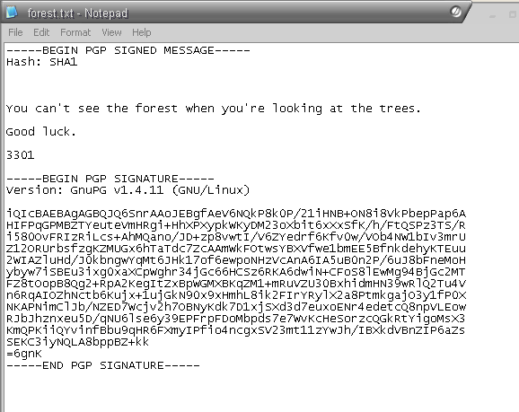  Along with old ones:  Code:  -----BEGIN PGP SIGNED MESSAGE-----  Hash: SHA1  @1231507051321  The key is all around you.  Good luck.  3301  -----BEGIN PGP SIGNATURE-----  Poem hidden in mp3  Code:  The Instar Emergence  Parable 1,595,277,641  Like the instar, tunneling to the surface  We must shed our own circumferences;  Find the divinity within and emerge.  Other loose ends are missing primes, wisdom/folley files, png image, GEMATRIA PRIMUS CHART, 560.17 file  Twin primes, palindromes ,emirps and Rhonda Numbers are special numbers we found until now and alot of all present primes.

CICADA 3301 recruiting round 2 2013

Page 2 of 3 [38 Posts] | Goto page: Previous 1, 2, 3 Next

 | Author |  | Message
 | bambusar  Unfettered    Joined: 02 May 2012  Posts: 639 |  | we have new toy and dead drop locations  MURALLY http://mrl.li/X2p8Ry  NEW ONION PAGE:  Code:  -----BEGIN PGP SIGNED MESSAGE-----  Hash: SHA1  Well done. You have come far.  pklmx2eeh6fjt7zf.onion  Good luck.  3301  -----BEGIN PGP SIGNATURE-----  DEAD DROP LOCATIONS  OKINAWA  26.41968, 127.73254  https://maps.google.com/maps?oe=utf-8&client=firefox-a&q=26.41968,+127.73254&ie=UTF-8&hq=&hnear=0x34e510d0f756e3e5:0x9d1fe888e30dd144,%2B26%C2%B0+25%27+11.40%22,+%2B127%C2%B0+43%27+56.78%22&ei=lsb1UPHoE8j2sgaZ3YDgDA&ved=0CDIQ8gEwAA  MARYLAND  38.977845, -76.486451  https://maps.google.com/maps?hl=en&client=firefox-a&q=38.977845,+-76.486451&ie=UTF-8&hq=&hnear=0x89b7f64f3ee38feb:0x340b6ce3dadef1a7,%2B38%C2%B0+58%27+40.33%22,+-76%C2%B0+29%27+11.28%22&ei=bYj1UPWJDsOE4gTtuIFI&ved=0CC8Q8gEwAA  Annapolis Maryland  WE ARE EXPECTNG POSTERS LIKE LAST YEAR
 |  |  | Posted: Tue Jan 15, 2013 6:38 pm
 | bambusar  Unfettered    Joined: 02 May 2012  Posts: 639 |  | We got two more locations OREGON AND TEXAS  we got the first code from Oregon    more:  http://uncovering-cicada.wikia.com/wiki/Phone_Number_from_Portland  http://point-at-infinity.org/ssss/
 |  |  | Posted: Thu Jan 17, 2013 8:28 am
 | bambusar  Unfettered    Joined: 02 May 2012  Posts: 639 |  | New drop found on okinawa:  We need 5 of them to succesfully decrypt the messsage: http://point-at-infinity.org/ssss/    STATUS  GOT IT:  "+1 626-586-1033 Access: Y F"  CALL  https://www.dropbox.com/s/1s5scffk5n5by70/WS_10001.WMA  Transcription : Dataset 13 : Offset 37861 : Data : f286b8438cb85eb191ec7bf10a28a54ec06f9a27eb91c5  (17.1.2013 04:50 GMT) WE GOT REPORT FROM OKINAWA:  Be advised, we've conducted a sweep of the objective and  recovered one document.  Document reads as follows: +1 626-586-1033 Access: Y F  http://imgur.com/a/17v5k  http://i50.tinypic.com/4q3f60.jpg  http://i45.tinypic.com/25yxj4j.jpg  http://uncovering-cicada.wikia.com/wiki/Phone_Number_from_Portland <--explanation what we are doing with posters to found new onion pages on TOR
 |  |  | Posted: Thu Jan 17, 2013 11:32 am
 | bambusar  Unfettered    Joined: 02 May 2012  Posts: 639 |  | NEW DROPS: we need people in Columbus GA and Greenville TX  Columbus GA  Last-Modified: Thu, 17 Jan 2013 20:30:01 GMT  -----BEGIN PGP SIGNED MESSAGE-----  Hash: SHA1  32.478944, -84.983674  -----BEGIN PGP SIGNATURE-----  POSTED on onion : Thu, 17 Jan 2013 20:30:01 GMT  MAP:  http://goo.gl/maps/wSNwS  http://prntscr.com/pir9n  Street view:  http://prntscr.com/pisbj  http://goo.gl/maps/VvDln  PGP:  http://prntscr.com/piruf  PGP TIMESTAMP: 17. 1. 20:28  Greenville, Texas.  -----BEGIN PGP SIGNED MESSAGE-----  Hash: SHA1  33.092817, -96.08265  -----BEGIN PGP SIGNATURE-----  https://maps.google.com/maps?q=33.092817,+-96.08265&hl=en&ll=33.092746,-96.082596&spn=0.003811,0.008256&sll=37.0625,-95.677068&sspn=57.902911,135.263672&t=h&z=18  TIME POSTED: Thu, 17 Jan 2013 12:51:25 GMT  http://www.anonpaste.me/anonpaste2/index.php?8f0fd66579170c36#NFNIgRS+RQgTdMPjauGW+wFjAgbkkIbnolYknMpqjgY=  PGP:http://prntscr.com/pgtd6  PGP time: 15.1. 20:50  map:
 |  |  | Posted: Thu Jan 17, 2013 8:01 pm
 | GuestUser17  Unfettered  Joined: 22 Feb 2011  Posts: 665 |  | Had problems with irc but will head to Columbus tomorrow if roads are OK.
 |  |  | Posted: Thu Jan 17, 2013 9:10 pm
 | bambusar  Unfettered    Joined: 02 May 2012  Posts: 639 |  | No need we have Columbus already  Found posters do far:  Greenville, Texas (retrieved)  OKINAWA (retrieved)  Annapolis,MARYLAND (torn down)  Portland OREGON (retrieved)  Columbus GEORGIA (retrieved)  You can find info in wiki  http://uncovering-cicada.wikia.com/wiki/Columbus_GEORGIA  ---------------------------------------------------------------------------  MORE NEWS  This coords are coming from this onion adress:  http://pklmx2eeh6fjt7zf.onion  http://pklmx2eeh6fjt7zf.onion.to if you dont have TOR  WE HAVE THREE NEW LOCATIONS  Russia, Moscow  55.793765, 37.578608  http://goo.gl/maps/nE8tx  Granada, Spain  37.182685, -3.605801  http://goo.gl/maps/VjV6p  Little Rock, Arkansas  34.7477910, -92.2690863  http://goo.gl/maps/Y03X7
Posted: Sat Jan 19, 2013 6:03 pm
Last edited by bambusar on Sat Jan 19, 2013 6:30 pm; edited 1 time in total
 | bambusar  Unfettered    Joined: 02 May 2012  Posts: 639 |  | Another NEWS  WE got all 5 codes necessary to solve SSSS message.  http://point-at-infinity.org/ssss/  http://en.wikipedia.org/wiki/Shamir%27s_Secret_Sharing  Result was surprising onion page with test that allows us to submit out email to CICADA 3301.  If you want to participate:  http://uncovering-cicada.wikia.com/wiki/SSSS_Code_List  Let this Pastebin be your guide to the depths :  http://pastebin.com/7vVyFJhz <-----ALL 5 NEEDED CODES  (if you participate, please do not publish onion link with submit email form and test, keep it a bit hidden so people have to at least decode it for themself, it is really not hard)
 |  |  | Posted: Sat Jan 19, 2013 6:16 pm
 | netsua98  Unfettered    Joined: 22 Dec 2011  Posts: 449  Location: Florida |  | anything in florida?
_________________
ARGing, Authoring, PMing, Producing, Composing, Living
Posted: Sun Jan 20, 2013 7:58 pm
 | bambusar  Unfettered    Joined: 02 May 2012  Posts: 639 |  | No FL for now. But we expect at least two more drops. We found poster in Moscow and Arkansas  We are still working on Spain one.  Ru and US posters had phonenumbers with same set of SSSS codes as previous posters, leading to submit email and pass test page.  No emails from cicada were received yet.  If you decided to pass the test and dont know how to create PGP certificate for your email here is tha link with all information you need.  http://uncovering-cicada.wikia.com/wiki/HOW_DO_I_CREATE_MA_PGP_KEY%3F  And yes you need to create it and upload it to MIT server, if you dont you wont be able to decrypt message Cicad will send you back.  Onion for test page:  p7amjopgric7dfdi.onion (it works in clearnet without tor if you use .to; p7amjopgric7dfdi.onion.to)  Retrieved Drops:  Moscow:  http://uncovering-cicada.wikia.com/wiki/Moscow_RUSSIA  Arkansas  http://uncovering-cicada.wikia.com/wiki/Little_Rock,_Arkansas,_US
 |  |  | Posted: Wed Jan 23, 2013 8:51 am
 | magnet0  Unfettered    Joined: 05 Apr 2008  Posts: 391 |  | bambusar wrote:  (if you participate, please do not publish onion link with submit email form and test, keep it a bit hidden so people have to at least decode it for themself, it is really not hard)  Interesting psychological/capability test.
_________________
1 / ∞ ≠ 0
Posted: Thu Jan 24, 2013 12:29 pm
 | bambusar  Unfettered    Joined: 02 May 2012  Posts: 639 |  | we got emails...  things are strictly technical now, we have to build TCP server with half dozen of different functions, and put it on TOR...  not sure if i can publish it but what the hell:  http://www.anonpaste.me/anonpaste2/index.php?0c95e622e0eaca5c#um3v6b/XyiEdVfpZh0NEbZnvS+wMfVgMBxP0vqOaEtM=
 |  |  | Posted: Sat Jan 26, 2013 10:45 pm
 | magnet0  Unfettered    Joined: 05 Apr 2008  Posts: 391 |  | I got the email and put together a simple TCP server in Python but I was wondering if I should finish off the code with explanatory comment lines and true error checking?  Are we going to have to actually implement this simple server?  the NEXT command instructions wrote:  The server MUST record this. This data will be the next set of instructions.
_________________
1 / ∞ ≠ 0
Posted: Mon Jan 28, 2013 1:41 pm
 | bambusar  Unfettered    Joined: 02 May 2012  Posts: 639 |  | I resigned, not competent enough to help you atall, but you are free to join us on IRC and ask other people to help you.  But yes you have to put that TCP server up and send onion address to 3301 so they can check it and leave next instructions to you.  http://webchat.freenode.net/?channels=33012013  IRC channel is still up and running as before.  Wiki is not updated anymore since people now work individually.
 |  |  | Posted: Mon Jan 28, 2013 2:09 pm
 | magnet0  Unfettered    Joined: 05 Apr 2008  Posts: 391 |  | I sent in my server example on Sunday but haven't heard anything back, yet. Has anyone else received further instructions?  The deadline was listed as 00:00 on Feb 3. Did this mean midnight between Feb 2 and 3 or midnight between Feb 3 and 4? I always get those confused. Meh, if I missed the deadline at least I learned a little Python programming.
_________________
1 / ∞ ≠ 0
Posted: Wed Feb 06, 2013 8:20 am
 | bambusar  Unfettered    Joined: 02 May 2012  Posts: 639 |  | until now nobody got any visits

CICADA 3301 recruiting round 2 2013

Page 3 of 3 [38 Posts] | Goto page: Previous 1, 2, 3

 | Author |  | Message
 | magnet0  Unfettered    Joined: 05 Apr 2008  Posts: 391 |  | Maybe I should turn back on my little server then??
_________________
1 / ∞ ≠ 0
Posted: Tue Feb 12, 2013 8:11 am
 | bambusar  Unfettered    Joined: 02 May 2012  Posts: 639 |  | i would agree  none reported any real visit apart for some random short connections, we have no idea where they came from  its hard to imagine that some bots would be able to find onion addresses by random  but you never know what china is up to
 |  |  | Posted: Fri Feb 15, 2013 5:30 am
 | bambusar  Unfettered    Joined: 02 May 2012  Posts: 639 |  | People started to get visits on TCP servers after one month of Cicada going dark.  http://uncovering-cicada.wikia.com/wiki/Uncovering_Cicada_Wiki  Also Wind visited our IRC one day ago, Wind is nutorious character that played important role on IRC during Cicada 3301 in 2012 puzzle. Winds affiliation to 33301 was never confirmed.  Posting two quotes from LOGs that are showing little insights in how cicada is organized.  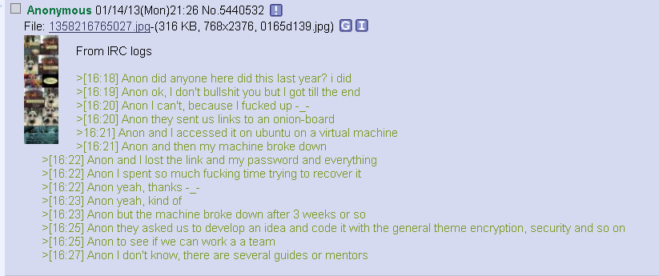
 |  |  | Posted: Sun Mar 03, 2013 10:54 am
 | bambusar  Unfettered    Joined: 02 May 2012  Posts: 639 |  | I ll just add some things here that would maybe interest people reading this thread.  We are still hanging around in #33012013 on freenode IRC. You can find us there. Just idle for an hour or two if nobody answers, sooner or later someone will answer.  Nobody admitted that he was recruited in 2013, it looks just like 3301 went dark, but it is also possible that some were contacted but didnt tell about it.  Few more people who were invited in 2012 stopped in channel and complained that they lost contact to 3301 when their onion board disappeared.  Here are some logs of most interesting perts of that:  http://sebsauvage.net/paste/?459f0f4bf629ef1b#lroIENKI9LPGBAUv5K8NelwPyGVjQx97AMNzlPiw0Z4=  Some of them shared few things from inner organization of "0H brood" as 2012 group was called.  Here are screenshots of other people on other forums complaining about loosing contact with 2012 group, from hackforums: http://imgur.com/a/uX40f    Our wiki is still being edited and it is slowly getting some decent form: http://uncovering-cicada.wikia.com/wiki/Uncovering_Cicada_Wiki  There is page on wikipedia also: http://en.wikipedia.org/wiki/Cicada_3301  Maybe interesting:  Someone is posting images of CICADA 3301 logo stickers on 4chan /x/ recently. There is thread about 3301 on it every few weeks.  Pictures (we found 3 for now) and archived threads can be found here:  (note: we do not know who is publishing this, in #33012013 nobody admits being op of those threads)  http://uncovering-cicada.wikia.com/wiki/The_Cicada_Sticker  http://uncovering-cicada.wikia.com/wiki/4chan_/x/_thread_on_september_2013  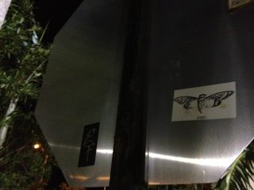
Posted: Mon Sep 16, 2013 8:52 pm
Last edited by bambusar on Fri Nov 29, 2013 2:50 am; edited 3 times in total
 | bambusar  Unfettered    Joined: 02 May 2012  Posts: 639 |  | Recent article in The Telegtaph (telegraph.co.uk)  http://www.telegraph.co.uk/technology/internet/10468112/The-internet-mystery-that-has-the-world-baffled.html  sparked new interest in 3301.  Here are some articles:  http://uncovering-cicada.wikia.com/wiki/November_2013_media_exposure
 |  |  | Posted: Thu Nov 28, 2013 2:55 am
 | corndogulous  Kilroy  Joined: 06 Dec 2013  Posts: 1 |  | seeking subjects for possible cicada documentary  Greetings,  We are a group of award-winning documentary filmmakers who are interested in covering the 2014 cicada puzzle (if it indeed happens again). If you are planning on attempting cicada 2014, and would like to have your quest documented on camera, please email cicada3301movieSPLATgmail.com and tell us your location, age, occupation, and a little something about your previous experience with cicada 3301.  We assure you this is not a part of any puzzle/ARG, and that we are sincere, professional filmmakers who are simply in search of a great story about some of the smartest people in the world.  Thanks for letting us post here and we look forward to getting some replies.
 |  |  | Posted: Fri Dec 06, 2013 7:06 pm
 | SimonTheSorcerer  Kilroy  Joined: 06 Jan 2014  Posts: 1 |  | Cicada 3301 postponed?  For those out there who doubt this, they need to lurk moar. This is real. For those with "weird" (I did not want to us stronger, harsher terms...) notions about satanic/masonic/alien--hybrid conspiracies you need to take your medication.  But it might not happen this year, it already the 6th January in many places in the world, they are late already.  At least we will have plenty of time to prepare.  See you on the IRC!  http://simonsblogpark.com/personal/prepare-cicada-3301-hunt-january-5th-2014-solve-puzzles/
 |  |  | Posted: Mon Jan 06, 2014 12:56 am
 | AtenSet  Greenhorn  Joined: 07 Jan 2014  Posts: 7 |  | Should I go to the wiki to follow/ contribute? ( the chat room was glitchy)  anyways, i just wanted to say that this picture http://static2.wikia.nocookie.net/__cb20140106081530/uncovering-cicada/images/9/93/1033.jpg  could be interpreted as illustrating the enochian tartarus and the devil's hell. Just food for thought; one misinterpretation probably could link to a whole stream of false bread crumbs.

